MOS-Field-Effect Transistor

### 1.)

### Measure the output characteristics ID = f(UDS) of a MOS-FET in the current range of

### 0 <ID £<2 mA and the voltage range of 0 < UDS < 10V for 5 different values of gate-source

### Voltage UGS.

In the task, the output characteristic of the MOS-FET transistor

recorded with the help of x-y recorder.

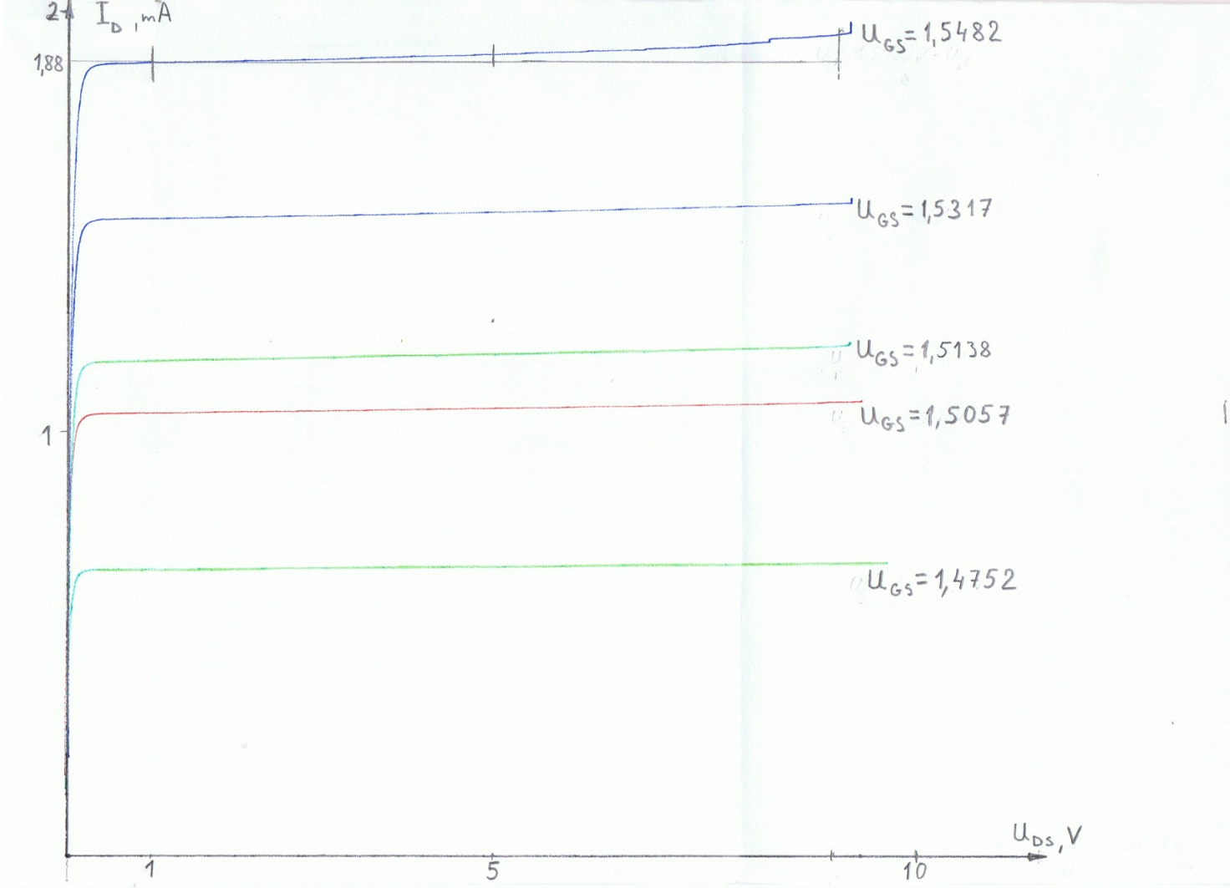

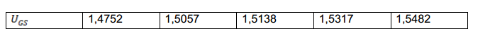The output characteristic is the relationship between the drain current ID and

the drain-source voltage UDS in response to the gate-source voltage UGS

UTO=UTH=0,8V( determined graphically, see Task 2)

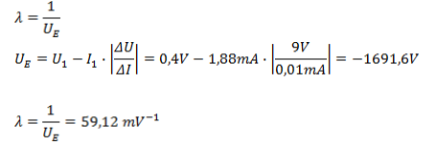

2.)

Measure the transfer characteristics ID = f(UGS) of the same MOS-FET for a constant voltage

UDS = 5V in the current range of 0 < ID <2mA.

Read the threshold voltage Uth and the transconductance parameter b from your diagram,

the last for an operating point of ID = 0.4mA.

To record the transfer characteristic we use the same

Circuit as in the first task, but the x-axis of the xy-recorder is connected to UGS.

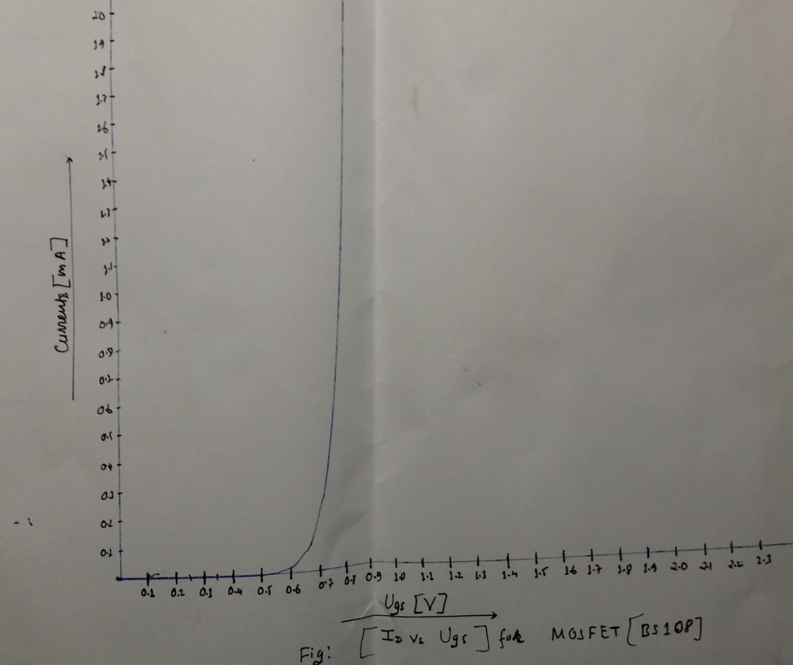

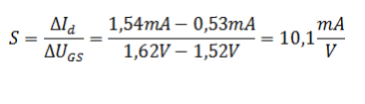

### 3-set up a CMOS –inverter according to the circuit draw the characteristic Uout=f(Uin)and I=f(Uin)with Uin ranging from zero to 5 v by means of an X-Y recorder

